Description of the process
It all starts with the Retailer creating and processing a purchase order. Once the order is sent, the Sales & Planning department of the Fruit Distributor reviews its inventory stock database to determine if they have sufficient stock to send the order. If the stock is not available, the Sales & Planning team needs to request fruit from the grower and then wait for it to be transported. Once the stock is confirmed to be adequate, the Operations and Warehouse department will sort the fruit according to ripeness and quality.
Once the sorting is done, two activities take place: the warehouse team places the fruit into crates for retailing, while the shipping manifest is created. Once both these tasks are complete, the fruit must undergo a cooling period. The workers wait until the internal temperature reaches 4°C. When this temperature is achieved, the Operations team will load the crates into a refrigerated truck and deliver the order. The Retailer then takes delivery and unloads the crates at their warehouse. Once unloading is finished, the Retailer’s stock is replenished, and the business process is complete. This process guarantees quality control is upheld via Retailer-Warehouse communication.

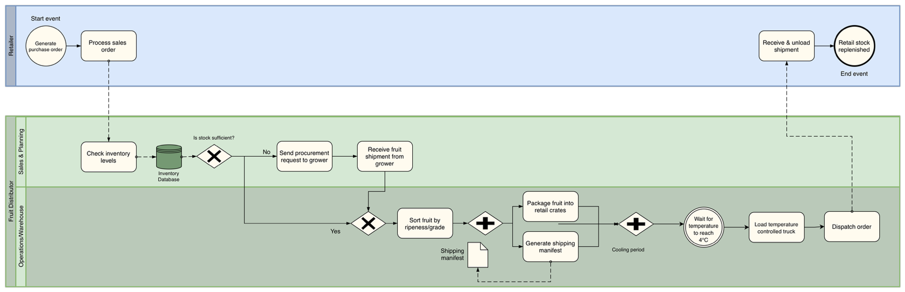
The Business Process Model (BPMN model)
Figure 1.1 The BPMN model of Fruit Distribution Workflow
Motivation
The fruit industry supply chain model was chosen, because it is a great example of a demand-driven business process. Unlike a standard office workflow, managing perishable goods requires strict quality checks and specific timing for storage. This allowed me to create a realistic model that includes complex gateways and time-sensitive events that occur in real-world logistics.

Analysis & Optimization suggestion
The BPMN model seems to have two notable inefficiencies throughout the process, which could be improved. First, there is an inefficiency in the inventory check and procurement decision in the Sales & Planning lane. Currently, these processes are done manually by a human: checking inventory levels against a database and decides whether to send a procurement request to the grower. This particular step is a bottleneck, because if staff are unavailable, delayed, or working with outdated data, the entire process stalls. This step could be automated with the help of AI. It would be continuously monitoring inventory levels in real time, predicting depletion rates based on sales patterns, and send out a procurement request automatically, before stock runs critically low. These improvements could minimize reaction delays and reduce the risk of stockouts, improving both speed and reliability.
Second inefficiency can be observed in the step where fruit is sorted by ripened and grade in Operations/Warehouse lane. This is a manual task as well, creating yet another bottleneck in the whole process. With AI, computers could detect and classify fruit by ripeness, size and quality rate in real time using vision systems. This would significantly decrease the time and costs spent on this manual labor, enhancing customer satisfaction and reducing waste from misplaced products.

